Iteration 2

CIS 320-02

Team: BusinessFirst

**Alexander Welsh, Dalton Karl, Anthony Striepe, Jrew Simpson, La’Daysha Wade**

**Worth the Words**

**Vision (Small Project)**

**Version 1.1**

***Revision History***

|  |  |  |  |
| --- | --- | --- | --- |
| **Date** | **Version** | **Description** | **Author** |
| **9-11** | **1.0** | **Iteration 1** | **BusinessFirst** |
| **10-14** | **1.1** | **Iteration 2** | **BusinessFirst** |
|  |  |  |  |

**Table of Contents**

Table of Contents

[Introduction 3](https://word-edit.officeapps.live.com/we/wordeditorframe.aspx?ui=en-US&rs=en-US&wopisrc=https%3A%2F%2Fcardmaillouisville-my.sharepoint.com%2Fpersonal%2Falstri02_louisville_edu%2F_vti_bin%2Fwopi.ashx%2Ffiles%2F3d93b0e6260a465292e7de8fadcb77ea&wdenableroaming=1&mscc=1&wdodb=1&hid=A3E459A1-005E-6000-9D20-91B94F8E295D.0&uih=sharepointcom&wdlcid=en-US&jsapi=1&jsapiver=v2&corrid=150aef0b-f6f3-3a3b-aee6-532ba6fa6f5a&usid=150aef0b-f6f3-3a3b-aee6-532ba6fa6f5a&newsession=1&sftc=1&uihit=docaspx&muv=1&cac=1&sams=1&mtf=1&sfp=1&sdp=1&hch=1&hwfh=1&dchat=1&sc=%7B%22pmo%22%3A%22https%3A%2F%2Fcardmaillouisville-my.sharepoint.com%22%2C%22pmshare%22%3Atrue%7D&ctp=LeastProtected&rct=Normal&wdorigin=OWA-NT-Mail.Sharing.DirectLink.Copy&wdhostclicktime=1728927585267&instantedit=1&wopicomplete=1&wdredirectionreason=Unified_SingleFlush#_Toc179804414)

[Positioning 4](https://word-edit.officeapps.live.com/we/wordeditorframe.aspx?ui=en-US&rs=en-US&wopisrc=https%3A%2F%2Fcardmaillouisville-my.sharepoint.com%2Fpersonal%2Falstri02_louisville_edu%2F_vti_bin%2Fwopi.ashx%2Ffiles%2F3d93b0e6260a465292e7de8fadcb77ea&wdenableroaming=1&mscc=1&wdodb=1&hid=A3E459A1-005E-6000-9D20-91B94F8E295D.0&uih=sharepointcom&wdlcid=en-US&jsapi=1&jsapiver=v2&corrid=150aef0b-f6f3-3a3b-aee6-532ba6fa6f5a&usid=150aef0b-f6f3-3a3b-aee6-532ba6fa6f5a&newsession=1&sftc=1&uihit=docaspx&muv=1&cac=1&sams=1&mtf=1&sfp=1&sdp=1&hch=1&hwfh=1&dchat=1&sc=%7B%22pmo%22%3A%22https%3A%2F%2Fcardmaillouisville-my.sharepoint.com%22%2C%22pmshare%22%3Atrue%7D&ctp=LeastProtected&rct=Normal&wdorigin=OWA-NT-Mail.Sharing.DirectLink.Copy&wdhostclicktime=1728927585267&instantedit=1&wopicomplete=1&wdredirectionreason=Unified_SingleFlush#_Toc179804415)

[Problem Statement 4](https://word-edit.officeapps.live.com/we/wordeditorframe.aspx?ui=en-US&rs=en-US&wopisrc=https%3A%2F%2Fcardmaillouisville-my.sharepoint.com%2Fpersonal%2Falstri02_louisville_edu%2F_vti_bin%2Fwopi.ashx%2Ffiles%2F3d93b0e6260a465292e7de8fadcb77ea&wdenableroaming=1&mscc=1&wdodb=1&hid=A3E459A1-005E-6000-9D20-91B94F8E295D.0&uih=sharepointcom&wdlcid=en-US&jsapi=1&jsapiver=v2&corrid=150aef0b-f6f3-3a3b-aee6-532ba6fa6f5a&usid=150aef0b-f6f3-3a3b-aee6-532ba6fa6f5a&newsession=1&sftc=1&uihit=docaspx&muv=1&cac=1&sams=1&mtf=1&sfp=1&sdp=1&hch=1&hwfh=1&dchat=1&sc=%7B%22pmo%22%3A%22https%3A%2F%2Fcardmaillouisville-my.sharepoint.com%22%2C%22pmshare%22%3Atrue%7D&ctp=LeastProtected&rct=Normal&wdorigin=OWA-NT-Mail.Sharing.DirectLink.Copy&wdhostclicktime=1728927585267&instantedit=1&wopicomplete=1&wdredirectionreason=Unified_SingleFlush#_Toc179804416)

[Product Position Statement 4](https://word-edit.officeapps.live.com/we/wordeditorframe.aspx?ui=en-US&rs=en-US&wopisrc=https%3A%2F%2Fcardmaillouisville-my.sharepoint.com%2Fpersonal%2Falstri02_louisville_edu%2F_vti_bin%2Fwopi.ashx%2Ffiles%2F3d93b0e6260a465292e7de8fadcb77ea&wdenableroaming=1&mscc=1&wdodb=1&hid=A3E459A1-005E-6000-9D20-91B94F8E295D.0&uih=sharepointcom&wdlcid=en-US&jsapi=1&jsapiver=v2&corrid=150aef0b-f6f3-3a3b-aee6-532ba6fa6f5a&usid=150aef0b-f6f3-3a3b-aee6-532ba6fa6f5a&newsession=1&sftc=1&uihit=docaspx&muv=1&cac=1&sams=1&mtf=1&sfp=1&sdp=1&hch=1&hwfh=1&dchat=1&sc=%7B%22pmo%22%3A%22https%3A%2F%2Fcardmaillouisville-my.sharepoint.com%22%2C%22pmshare%22%3Atrue%7D&ctp=LeastProtected&rct=Normal&wdorigin=OWA-NT-Mail.Sharing.DirectLink.Copy&wdhostclicktime=1728927585267&instantedit=1&wopicomplete=1&wdredirectionreason=Unified_SingleFlush#_Toc179804417)

[Stakeholder and User Descriptions 5](https://word-edit.officeapps.live.com/we/wordeditorframe.aspx?ui=en-US&rs=en-US&wopisrc=https%3A%2F%2Fcardmaillouisville-my.sharepoint.com%2Fpersonal%2Falstri02_louisville_edu%2F_vti_bin%2Fwopi.ashx%2Ffiles%2F3d93b0e6260a465292e7de8fadcb77ea&wdenableroaming=1&mscc=1&wdodb=1&hid=A3E459A1-005E-6000-9D20-91B94F8E295D.0&uih=sharepointcom&wdlcid=en-US&jsapi=1&jsapiver=v2&corrid=150aef0b-f6f3-3a3b-aee6-532ba6fa6f5a&usid=150aef0b-f6f3-3a3b-aee6-532ba6fa6f5a&newsession=1&sftc=1&uihit=docaspx&muv=1&cac=1&sams=1&mtf=1&sfp=1&sdp=1&hch=1&hwfh=1&dchat=1&sc=%7B%22pmo%22%3A%22https%3A%2F%2Fcardmaillouisville-my.sharepoint.com%22%2C%22pmshare%22%3Atrue%7D&ctp=LeastProtected&rct=Normal&wdorigin=OWA-NT-Mail.Sharing.DirectLink.Copy&wdhostclicktime=1728927585267&instantedit=1&wopicomplete=1&wdredirectionreason=Unified_SingleFlush#_Toc179804418)

[Stakeholder Summary 5](https://word-edit.officeapps.live.com/we/wordeditorframe.aspx?ui=en-US&rs=en-US&wopisrc=https%3A%2F%2Fcardmaillouisville-my.sharepoint.com%2Fpersonal%2Falstri02_louisville_edu%2F_vti_bin%2Fwopi.ashx%2Ffiles%2F3d93b0e6260a465292e7de8fadcb77ea&wdenableroaming=1&mscc=1&wdodb=1&hid=A3E459A1-005E-6000-9D20-91B94F8E295D.0&uih=sharepointcom&wdlcid=en-US&jsapi=1&jsapiver=v2&corrid=150aef0b-f6f3-3a3b-aee6-532ba6fa6f5a&usid=150aef0b-f6f3-3a3b-aee6-532ba6fa6f5a&newsession=1&sftc=1&uihit=docaspx&muv=1&cac=1&sams=1&mtf=1&sfp=1&sdp=1&hch=1&hwfh=1&dchat=1&sc=%7B%22pmo%22%3A%22https%3A%2F%2Fcardmaillouisville-my.sharepoint.com%22%2C%22pmshare%22%3Atrue%7D&ctp=LeastProtected&rct=Normal&wdorigin=OWA-NT-Mail.Sharing.DirectLink.Copy&wdhostclicktime=1728927585267&instantedit=1&wopicomplete=1&wdredirectionreason=Unified_SingleFlush#_Toc179804419)

[User Summary 6](https://word-edit.officeapps.live.com/we/wordeditorframe.aspx?ui=en-US&rs=en-US&wopisrc=https%3A%2F%2Fcardmaillouisville-my.sharepoint.com%2Fpersonal%2Falstri02_louisville_edu%2F_vti_bin%2Fwopi.ashx%2Ffiles%2F3d93b0e6260a465292e7de8fadcb77ea&wdenableroaming=1&mscc=1&wdodb=1&hid=A3E459A1-005E-6000-9D20-91B94F8E295D.0&uih=sharepointcom&wdlcid=en-US&jsapi=1&jsapiver=v2&corrid=150aef0b-f6f3-3a3b-aee6-532ba6fa6f5a&usid=150aef0b-f6f3-3a3b-aee6-532ba6fa6f5a&newsession=1&sftc=1&uihit=docaspx&muv=1&cac=1&sams=1&mtf=1&sfp=1&sdp=1&hch=1&hwfh=1&dchat=1&sc=%7B%22pmo%22%3A%22https%3A%2F%2Fcardmaillouisville-my.sharepoint.com%22%2C%22pmshare%22%3Atrue%7D&ctp=LeastProtected&rct=Normal&wdorigin=OWA-NT-Mail.Sharing.DirectLink.Copy&wdhostclicktime=1728927585267&instantedit=1&wopicomplete=1&wdredirectionreason=Unified_SingleFlush#_Toc179804420)

[User Environment 8](https://word-edit.officeapps.live.com/we/wordeditorframe.aspx?ui=en-US&rs=en-US&wopisrc=https%3A%2F%2Fcardmaillouisville-my.sharepoint.com%2Fpersonal%2Falstri02_louisville_edu%2F_vti_bin%2Fwopi.ashx%2Ffiles%2F3d93b0e6260a465292e7de8fadcb77ea&wdenableroaming=1&mscc=1&wdodb=1&hid=A3E459A1-005E-6000-9D20-91B94F8E295D.0&uih=sharepointcom&wdlcid=en-US&jsapi=1&jsapiver=v2&corrid=150aef0b-f6f3-3a3b-aee6-532ba6fa6f5a&usid=150aef0b-f6f3-3a3b-aee6-532ba6fa6f5a&newsession=1&sftc=1&uihit=docaspx&muv=1&cac=1&sams=1&mtf=1&sfp=1&sdp=1&hch=1&hwfh=1&dchat=1&sc=%7B%22pmo%22%3A%22https%3A%2F%2Fcardmaillouisville-my.sharepoint.com%22%2C%22pmshare%22%3Atrue%7D&ctp=LeastProtected&rct=Normal&wdorigin=OWA-NT-Mail.Sharing.DirectLink.Copy&wdhostclicktime=1728927585267&instantedit=1&wopicomplete=1&wdredirectionreason=Unified_SingleFlush#_Toc179804423)

[Summary of Key Stakeholder or User Needs 8](https://word-edit.officeapps.live.com/we/wordeditorframe.aspx?ui=en-US&rs=en-US&wopisrc=https%3A%2F%2Fcardmaillouisville-my.sharepoint.com%2Fpersonal%2Falstri02_louisville_edu%2F_vti_bin%2Fwopi.ashx%2Ffiles%2F3d93b0e6260a465292e7de8fadcb77ea&wdenableroaming=1&mscc=1&wdodb=1&hid=A3E459A1-005E-6000-9D20-91B94F8E295D.0&uih=sharepointcom&wdlcid=en-US&jsapi=1&jsapiver=v2&corrid=150aef0b-f6f3-3a3b-aee6-532ba6fa6f5a&usid=150aef0b-f6f3-3a3b-aee6-532ba6fa6f5a&newsession=1&sftc=1&uihit=docaspx&muv=1&cac=1&sams=1&mtf=1&sfp=1&sdp=1&hch=1&hwfh=1&dchat=1&sc=%7B%22pmo%22%3A%22https%3A%2F%2Fcardmaillouisville-my.sharepoint.com%22%2C%22pmshare%22%3Atrue%7D&ctp=LeastProtected&rct=Normal&wdorigin=OWA-NT-Mail.Sharing.DirectLink.Copy&wdhostclicktime=1728927585267&instantedit=1&wopicomplete=1&wdredirectionreason=Unified_SingleFlush#_Toc179804422)

[Alternatives and Competition 9](https://word-edit.officeapps.live.com/we/wordeditorframe.aspx?ui=en-US&rs=en-US&wopisrc=https%3A%2F%2Fcardmaillouisville-my.sharepoint.com%2Fpersonal%2Falstri02_louisville_edu%2F_vti_bin%2Fwopi.ashx%2Ffiles%2F3d93b0e6260a465292e7de8fadcb77ea&wdenableroaming=1&mscc=1&wdodb=1&hid=A3E459A1-005E-6000-9D20-91B94F8E295D.0&uih=sharepointcom&wdlcid=en-US&jsapi=1&jsapiver=v2&corrid=150aef0b-f6f3-3a3b-aee6-532ba6fa6f5a&usid=150aef0b-f6f3-3a3b-aee6-532ba6fa6f5a&newsession=1&sftc=1&uihit=docaspx&muv=1&cac=1&sams=1&mtf=1&sfp=1&sdp=1&hch=1&hwfh=1&dchat=1&sc=%7B%22pmo%22%3A%22https%3A%2F%2Fcardmaillouisville-my.sharepoint.com%22%2C%22pmshare%22%3Atrue%7D&ctp=LeastProtected&rct=Normal&wdorigin=OWA-NT-Mail.Sharing.DirectLink.Copy&wdhostclicktime=1728927585267&instantedit=1&wopicomplete=1&wdredirectionreason=Unified_SingleFlush#_Toc179804423)

[Product Overview 9](https://word-edit.officeapps.live.com/we/wordeditorframe.aspx?ui=en-US&rs=en-US&wopisrc=https%3A%2F%2Fcardmaillouisville-my.sharepoint.com%2Fpersonal%2Falstri02_louisville_edu%2F_vti_bin%2Fwopi.ashx%2Ffiles%2F3d93b0e6260a465292e7de8fadcb77ea&wdenableroaming=1&mscc=1&wdodb=1&hid=A3E459A1-005E-6000-9D20-91B94F8E295D.0&uih=sharepointcom&wdlcid=en-US&jsapi=1&jsapiver=v2&corrid=150aef0b-f6f3-3a3b-aee6-532ba6fa6f5a&usid=150aef0b-f6f3-3a3b-aee6-532ba6fa6f5a&newsession=1&sftc=1&uihit=docaspx&muv=1&cac=1&sams=1&mtf=1&sfp=1&sdp=1&hch=1&hwfh=1&dchat=1&sc=%7B%22pmo%22%3A%22https%3A%2F%2Fcardmaillouisville-my.sharepoint.com%22%2C%22pmshare%22%3Atrue%7D&ctp=LeastProtected&rct=Normal&wdorigin=OWA-NT-Mail.Sharing.DirectLink.Copy&wdhostclicktime=1728927585267&instantedit=1&wopicomplete=1&wdredirectionreason=Unified_SingleFlush#_Toc179804424)

[Product Features 1](https://word-edit.officeapps.live.com/we/wordeditorframe.aspx?ui=en-US&rs=en-US&wopisrc=https%3A%2F%2Fcardmaillouisville-my.sharepoint.com%2Fpersonal%2Falstri02_louisville_edu%2F_vti_bin%2Fwopi.ashx%2Ffiles%2F3d93b0e6260a465292e7de8fadcb77ea&wdenableroaming=1&mscc=1&wdodb=1&hid=A3E459A1-005E-6000-9D20-91B94F8E295D.0&uih=sharepointcom&wdlcid=en-US&jsapi=1&jsapiver=v2&corrid=150aef0b-f6f3-3a3b-aee6-532ba6fa6f5a&usid=150aef0b-f6f3-3a3b-aee6-532ba6fa6f5a&newsession=1&sftc=1&uihit=docaspx&muv=1&cac=1&sams=1&mtf=1&sfp=1&sdp=1&hch=1&hwfh=1&dchat=1&sc=%7B%22pmo%22%3A%22https%3A%2F%2Fcardmaillouisville-my.sharepoint.com%22%2C%22pmshare%22%3Atrue%7D&ctp=LeastProtected&rct=Normal&wdorigin=OWA-NT-Mail.Sharing.DirectLink.Copy&wdhostclicktime=1728927585267&instantedit=1&wopicomplete=1&wdredirectionreason=Unified_SingleFlush#_Toc179804425)0

**Vision (Small Project)**

# Introduction

The purpose of this document is to outline the main needs and features for the WIX website redesign of "Worth The Words." This project aims to meet the needs of key groups like funders, volunteers, community partners, and users. The goal is to increase engagement, improve the user experience, and make the organization more transparent. The redesign will make it easier to handle donations, organize volunteers, and manage content, helping "Worth The Words" achieve its mission more efficiently. This document also explains how the website will meet these needs through clear use cases and technical details.

# Positioning

## 2.1 Problem Statement

|  |  |
| --- | --- |
| The problem of | Ineffective user engagement  Limited donor conversion  Limited sponsor promotion  Limited user enrollment |
| Affects | Demarco Harris  Future children of Worth the Words |
| The impact of which is | Limited Longterm financial sustainability  Children will have less opportunities  Children won’t learn to process social and emotional trauma |
| A successful solution would be | Increased donations, enhanced community engagement, and streamlined volunteer coordination through an optimized website. |

## 2.2 Product Position Statement

|  |  |
| --- | --- |
| For | Nonprofits like Worth The Words |
| Who | Require a strong web presence to better connect with funders, volunteers, and the community |
| The (product name) | Worth The Words website redesign is a nonprofit-focused web solution |
| That | Offers a user-friendly platform for donations, volunteer coordination, and community engagement. |
| Unlike | Complex and costly alternatives, (WordPress, Drupal, or Joomla) |
| Our product | Is easy to maintain, cost-effective, and designed to meet the specific needs of nonprofits, ensuring smooth interactions with minimal technical expertise. |

# 

# Stakeholder and User Descriptions

To ensure that Worth The Words website redesign meets the needs of all stakeholders and users, we have identified the key groups involved in the project and outlined the main problems they perceive. This section provides a profile of the stakeholders and users, explaining their responsibilities and the challenges that the new website should address.

## 3.1 Stakeholder Summary

|  |  |  |
| --- | --- | --- |
| **Name** | **Description** | **Responsibilities** |
| *Leadership (Board of Directors and Executive)* | *Individuals who lead organizational projects, maintain organizational stability, and spearhead growth of the organization.* | *Ensures that the system will be maintainable*  *Ensures that there will be a market demand for the product’s features*  *Monitors the project’s progress*  *Approves funding*  *and so forth* |
| *Donors and Funders* | *Individuals and organizations that provide financial contributions to Worth The Words. They are a key stakeholder group, as the sustainability of the nonprofit relies heavily on their support.* | *Require a streamlined, secure donation process that allows for one-time and recurring contributions.*  *Expect transparency and visibility on how their donations impact the organization and the community.*  *Look for evidence of the nonprofit's impact, such as success stories, project updates, and financial reports, to justify continued or increased support.*  *Engage with the nonprofit’s mission and understand the long-term goals through easily accessible information on the website.* |
| *Volunteers* | *Volunteers dedicate their time and skills to support the nonprofit’s operations and events. They may be one-time or long-term participants who rely on the website for organization and communication.* | *Require an easy-to-navigate platform to find, sign up for, and track volunteer opportunities.*  *Use the website to register for events, track volunteer hours, and communicate with event coordinators.*  *Need timely and accurate information on upcoming events and opportunities.*  *Expect the site to offer volunteer resources, such as training materials or instructions for specific roles.*  *Look for clear impact statements on how their volunteer contributions support the nonprofit’s mission.* |
| *Community Partners* | *Organizations, businesses, and individuals in the community collaborate with Worth The Words to sponsor events, provide resources, or offer support for its mission.* | *Require clear information on how to partner with the nonprofit, including opportunities for sponsorships, collaborations, or in-kind donations.*  *Expect the website to showcase past and current partnerships, providing visibility and recognition for their contributions.*  *Need to understand the process for becoming a partner and what is expected of them in terms of support and participation.* |

## 3.2 User Summary

|  |  |  |  |
| --- | --- | --- | --- |
| **Name** | **Description** | **Responsibilities** | **Stakeholder** |
| *Website Visitors* | *General visitors to the website, including community members, potential volunteers, and supporters who seek information about Worth The Words.* | *Browse content related to the organization’s mission, events, and current projects.*  *Use the site to explore ways to get involved, whether through volunteering, donating, or attending events.*  *Expect intuitive navigation to find specific information quickly, including donation options, event calendars, and contact details.*  *May subscribe to newsletters or social media to stay updated on the nonprofit’s progress and activities* | *Leadership, Donors* |
| *Content Managers* | *Internal staff responsible for regularly updating the website’s content. This role ensures that the website remains fresh, relevant, and aligned with ongoing campaigns and activities.* | *Manage updates to website pages, including adding new events, blog posts, and project updates.*  *Ensure that all content, such as event details, volunteer opportunities, and donation links, are accurate and up to date.*  *Maintain the site’s layout and design to reflect the organization's branding guidelines.*  *Handle the integration of multimedia content, such as photos, videos, and infographics, to engage users and keep the website visually appealing.*  *Ensure compliance with security standards to protect user data, particularly for donations and personal information provided by volunteers or donors.*  *Monitor site analytics to understand user engagement and adjust content accordingly.* | *Leadership, Volunteers* |
| *Volunteers* | *Individuals who participate in Worth The Words' events or initiatives, relying on the website for information and registration* | *Use the website to find and register for volunteer opportunities.*  *Access necessary information about their roles and responsibilities before participating in events.*  *Receive updates on future opportunities and track their hours and contributions through the site.*  *Provide feedback on their experience through volunteer surveys or forms on the website.* | *Leadership* |

## 3.3 User Environment

The target users of the "Worth The Words" website include funders, volunteers, community members, and internal staff.

**Number of people involved:** Volunteers may range from individuals to large groups depending on the project, while donors are typically individuals or organizations. This may grow as the organization expands.

**Task cycle:** Tasks such as donations or signing up for volunteer opportunities are quick, typically completed in a few minutes. Internal staff may spend more time updating content weekly.

**Environmental constraints:** Many users will access the website from mobile devices, making mobile optimization essential.

**Current platforms:** The existing website is outdated and doesn’t fully integrate with donation management platforms or volunteer coordination software.

**Future platforms:** The new site on WIX will need to be mobile-responsive and possibly integrate with third-party systems like PayPal for donations or Eventbrite for events.]

## 3.4 Summary of Key Stakeholder or User Needs

|  |  |  |  |  |  |
| --- | --- | --- | --- | --- | --- |
| **Need** | **Priority** | **Concerns** | **Current Solution** | **Proposed Solutions** | |
| Easy-to-use donation platform | High | Donors find current system cumbersome | Manual processing or PayPal links | | Integrated donation form, secure processing |
| Volunteer coordination | High | Difficult to sign up for opportunities | Spreadsheet management | | Simple sign-up forms and automated confirmations |
| Mobile access | Medium | Website not fully optimized for mobile | Desktop-focused design | | Mobile-optimized site on WIX |
| Content management | Medium | Outdated information and no easy updates | Little Knowledge on updating content | | User-friendly CMS in WIX for easier content updates |

## 3.5 Alternatives and Competition

Alternatives to the WIX solution include custom-built websites or using platforms like WordPress or Squarespace. Custom-built solutions offer more flexibility but are costly and complex, while WordPress provides extensive plugins and customization options but can be difficult to manage without technical expertise. Squarespace offers similar ease of use to WIX but may be more expensive and less flexible for future growth.

# Product Overview

4.1 Product Perspective

The WIX website redesign will be a standalone platform tailored to the needs of Worth The Words. It will serve as the primary digital interface for the organization’s fundraising and volunteer efforts. The new site will integrate with donation platforms (e.g., PayPal) and volunteer management systems (e.g., Eventbrite), ensuring seamless connections between fundraising and volunteer coordination activities. Mobile responsiveness and content management will be key components of the site, allowing for future scalability.

4.2 Assumptions and Dependencies

It is assumed that Worth The Words will be responsible for providing the content needed for the website redesign. The success of the project depends on integrating external platforms for donations and event management and ensuring that staff are trained to manage the website content using WIX's CMS tools.

# Product Features

The new website for "Worth The Words" will feature several key capabilities. Donation integration provides an easy-to-use and secure platform for one-time or recurring donations, integrated with PayPal and other payment systems. The volunteer sign-up and management system simplifies the process for users to register for opportunities, while an event calendar displays fundraisers and volunteer events, allowing users to RSVP. The website will be mobile-optimized, ensuring usability across all devices, and feature a content management system (CMS) to empower internal staff to update the site without needing technical expertise. The project showcase will highlight both ongoing and completed initiatives, emphasizing transparency and the impact of donations. Social media integration will allow users to follow and share content, increasing visibility, while a newsletter sign-up ensures supporters stay informed.

In terms of other requirements, the WIX platform will be used and must integrate with third-party systems like PayPal and Eventbrite. The website will need to perform quickly across devices and browsers, with an emphasis on usability, including accessibility standards for disabled users. Security is essential for handling donation transactions, ensuring data protection through encryption. Documentation, including user manuals and training materials, will help internal staff maintain the CMS and other website features efficiently.

**Donation Integration**

* + Provides an easy-to-use and secure donation platform.
  + Allows one-time and recurring donations.
  + Integrated with PayPal and other payment platforms for convenience.

1. **Volunteer Sign-Up and Management**
   * Facilitates a simple process for users to register for volunteer opportunities.
   * Automatically confirms registrations and tracks volunteer hours.
2. **Event Calendar**
   * Displays upcoming events, including fundraisers and volunteer opportunities.
   * Allows users to RSVP and receive event reminders.
3. **Mobile Optimization**
   * Ensures a fully responsive design for users accessing the website on mobile devices.
   * Maintains usability across all screen sizes without sacrificing functionality.
4. **Content Management System (CMS)** 
   * Empowers internal staff to easily update website content, including blogs, events, and project reports.
   * No technical expertise is required to manage updates, making maintenance simple.
5. **Project Showcase**
   * Highlights current and completed projects to increase transparency and community engagement.
   * Displays the impact of donations and volunteer efforts.
6. **Social Media Integration**
   * Integrates social media links and feeds to improve engagement and visibility.
   * Users can follow and share content directly from the website.
7. **Newsletter Sign-Up**
   * Provides users with the ability to subscribe to email updates.
   * Ensures supporters are informed about the latest news and opportunities.

6. Other Product Requirements

1. **Platform**:
   * WIX will be used as the development platform. It needs to integrate with third-party systems like PayPal and Eventbrite.
2. **Performance**:
   * The website must load quickly, even with media content, and perform consistently across various devices and browsers.
3. **Usability**:
   * The design should be user-friendly for both external visitors and internal staff responsible for managing content.
   * Accessibility standards must be followed to ensure the website is navigable for users with disabilities.
4. **Security**:
   * The system must ensure secure transactions, especially for donations, protecting user data through encryption.
5. **Documentation**:
   * Provide user manuals and online help features for internal staff to manage the website.
   * Training materials should be included to guide staff through the CMS system and ensure smooth operation.

**Feasibility Analysis**

**Narrative Explanation**  
  
 Worth the Words is a recognized 501(c)(3) non-profit organization that’s dedicated to providing musical opportunities to support and assist troubled youth. Since 2022, Mr. Harris has led the effort of providing both musical workshops and programs to youth in Louisville through donations and his own finances. Worth the Words currently has both a website and multiple social media pages to market itself to potential supporters but, the current website is missing many features that could strengthen Worth the Word’s marketing strategy and website user retention. Worth the Word’s currently uses Wix and PayPal for their web system which we plan to continue using but, we plan on upgrading the current Wix plan to Wix Core for its additional marketing, UI and security features. The backend of the system can be easily managed by Mr. Harris or a volunteer due to its user-friendly dashboard that can be used to manage all of the deployed Wix features.

**Technical Feasibility**  
  
 The webpage was originally created via a contractor for our client using Wix, and we plan to continue to use it. Wix gives strong ease of use for our client and the CMS doesn’t require knowledge of web development. PayPal is one of the most popular PMS services which will give many of our web visitors a streamlined process with donations. Wix along with its PayPal integration allows our client to easily continue to maintain the website after developments are made.   
  
**Economic Feasibility**  
  
 Wix has a large app market with some apps being free which can be used to add to our current recommendation and could even be used to add future features to the webpage. An example of this is the social stream application which can be used to add social media feeds so that webpage visitors can check out social media posts without visiting the social media webpage. We recommend using Wix’s Core plan to accomplish our business needs, which costs $29 a month. This equates to $348 per year, which is only 2.7% of the current account balance. While PayPal fortunately offers discounted rates to recognized 501(c)(3) non-profit organizations, our rate will only be 1.99% + $0.49 for every transaction which beats out any other payment system.

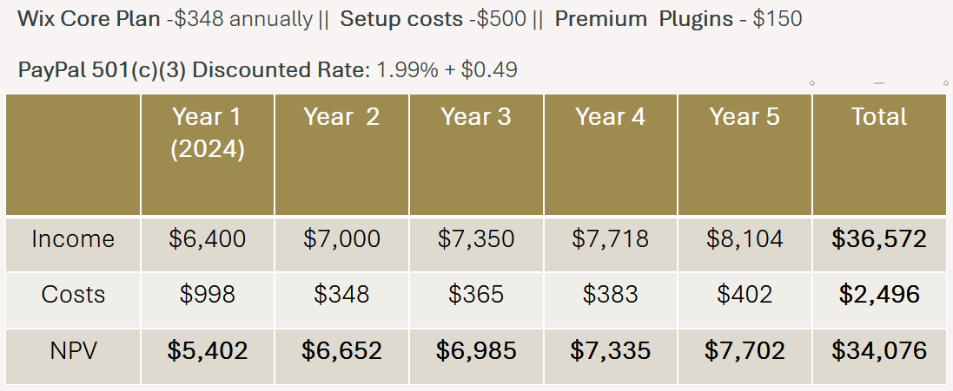  
**Organizational Feasibility**  
   
 The goal of this project is to increase support for our non-profit organization through web traffic. Since the organization is primarily run by our client alone, we believe the cost of Wix is worth the convenience that the service will provide. Along with Wix’s ease of use, it’s reported that 426 million people have PayPal accounts which will give our supporters a streamlined donation process. The new features for our website will make the best use of our web traffic by having an event page, interactive calendar and a volunteer apply page which will give our web visitors more options to get involved. The stakeholders will be pleased with the system because of the vast improvements it will provide to Worth the Words’s marketing strategy. The users will have more options to get involved such as a calendar with available/upcoming events with RSVP options and a volunteer application form.

**System Requirements**

**Functional Requirements**  
Event Calendar

ID: SR001 – The event calendar will display upcoming events.

ID: SR002 – The event calendar will display volunteer opportunities.

ID: SR003 – The event calendar will allow users to RSVP.

ID: SR004 – The event calendar will send users event reminders.

Volunteer Sign-Up

ID: SR005 – The volunteer sign-up will facilitate the process for users to register.

ID: SR006 – The volunteer sign-up will automatically confirm registrations.

Mobile Optimization

ID: SR007 – The mobile optimization will have a responsive design for mobile users.

ID: SR008 – The mobile optimization will maintain useability without sacrificing functionality.

Content Management System

ID: SR009 – The content management system will empower staff to easily update blogs.

ID: SR010 – The content management system will empower staff to easily update events.

ID: SR011 – The content management system will empower staff to easily update project reports.

ID: SR012 – The content management system will require no technical expertise.

Project Showcase

ID: SR013 – The project showcase will highlight current projects.

ID: SR014 – The project showcase will highlight completed projects.

ID: SR015 – The project showcase will increase transparency.

ID: SR016 – The project showcase will increase community engagement.

Social Media Integration

ID: SR017 – The social media integration will integrate social media links.

ID: SR018 – The social media integration will integrate social media feeds.

ID: SR019 – The social media integration will improve engagement.

ID: SR020 – The social media integration will improve visibility.

Newsletter Sign-Up

ID: SR021 – The newsletter sign-up will provide users with the ability to subscribe to email updates.

ID: SR022 – The newsletter sign-up will ensure supporters are informed about the latest news.

ID: SR023 – The newsletter sign-up will ensure supporters are informed about the latest opportunities.

Donation integration

ID: SR024 – The donation integration will provide an ease-of-use donation platform.

ID: SR025 – The donation integration will provide a secure donation platform.

ID: SR026 – The donation integration will allow one-time donations.

ID: SR027 – The donation integration will allow recurring donations.

ID: SR028 – The donation integration will be integrated with PayPal.

Song Catalog

ID: SR029 – The song catalog will list a number of songs made by youth participants.

ID: SR030 – The song catalog will have pause/play functionality.

ID: SR031 – The song catalog will have a volume slider.

ID: SR032 – The song catalog will have a share button for each song

Contact Form

ID: SR033 – The contact form will provide a simple outlet for questions

ID: SR034 – The contact form will increase community engagement

ID: SR035 – The contact form will provide opportunities for sponsors or partners to reach out

ID: SR036 – The contact form will have the option for submission to be viewed via email or Wix dashboard

**Non-Functional Requirements**

Sponsor Banner

ID: SR037 – The sponsor banner will show all organizations that have chosen to sponsor.

Reviews Section

ID: SR038 – The review section will show testimonies from youth participants and parents regarding their experiences with Worth the Words

Volunteer Hours Display

ID: SR039 – The volunteer hours widget will display the number of volunteer hours worked by Worth the Words volunteers.

**Use Cases**

**Use Case 1:** View Song Catalog  
Primary Actor: User  
Description: User can view the song catalog listed on the website  
Risk Level: Low

**Use Case 2:** Listen To Songs  
Primary Actor: User  
Description: User can click on different songs made by youth artists from the organization  
Risk Level: Low

**Use Case 3:** Manage Song Catalog  
Primary Actor: Admin  
Description: Admin can add or remove songs from the song catalog  
Risk Level: High

**Use Case 4:** Change Song Volume  
Primary Actor: User  
Description: User can use the volume slider to change the volume of the current song being played  
Risk Level: Low

**Use Case 5:** Share a Listed Song  
Primary Actor: User  
Description: User can click a button to share a song via social media  
Risk Level: Low

**Use Case 6:** View Program/Workshop Info  
Primary Actor: User  
Description: Curious users can view the information regarding provided programs and workshops   
Risk Level: Low

**Use Case 7:** Modify Program/Workshop Info  
Primary Actor: Admin  
Description: Admin can modify the information regarding the programs and workshops provided  
Risk Level: High

**Use Case 8:** Modify Layout/Fields of Contact Form  
Primary Actor: Admin  
Description: Admin has capability of modifying the layout of the contact form if necessary  
Risk Level: High (Contact form is critical to the system)

**Use Case 9:** Fill out fields in contact form  
Primary Actor: User  
Description: Users can fill out information in the contact form prior to clicking the submit button  
Risk Level: Low  
  
**Use Case 10:** Submit Contact Form  
Primary Actor: User  
Description: If the user has already filled out the fields in the contact form and ready to contact Worth the Words, they may click the submit button  
Risk Level: Low

**Use Case 11:** Read Contact Form Submissions  
Primary Actor: Admin  
Description: After users submit their contact forms, the admin can read the submissions.  
Risk Level: High (Could possibly contain sensitive data)

**Use Case 12:** Check/Uncheck Recurring Donation Box  
Primary Actor: User  
Description: Prior to submitting their donation, a user can make the donation recurring.  
Risk Level: High (Want to make sure the box is unchecked by default)

**Use Case 13:** Donate with PayPal  
Primary Actor: User  
Description: Users clicks option of donating with their PayPal account  
Risk Level: High (Data security)

**Use Case 14:** Donate with Debit or Credit Card  
Primary Actor: User  
Description: Users clicks option of donating with Debit or credit card.  
Risk Level: High (Data security)

**Use Case 15:** Donation Submit Button  
Primary Actor: User  
Description: After users fill out their donation information, they click the submit button  
Risk Level: High (Data security)

**Use Case 16:** Accept Donations  
Primary Actor: Admin  
Description: Administrator accepts the donation from PayPal's PMS  
Risk Level: High (Data security)

**Use Case 17:** Change Reviews  
Primary Actor: Admin  
Description: Administrator makes changes to the reviews  
Risk Level: High

**Use Case 18:** View Reviews  
Primary Actor: User  
Description: User views the reviews  
Risk Level: Low

**Use Case 19:** View Social Media  
Primary Actor: User  
Description: User views the integrated social media posts

Risk Level: Low

**Use Case 20:** Social Media Connection  
Primary Actor: Admin  
Description: Administrator connects a social media post to the website  
Risk Level: Low

**Use Case 21:** View Sponsors  
Primary Actor: User  
Description: User views the organizations that are sponsoring  
Risk Level: Low

**Use Case 22:** Update Sponsors  
Primary Actor: Admin  
Description: Administrator updates the organizations that are sponsoring  
Risk Level: Low

**Use Case 23:** View Mission Statement  
Primary Actor: User  
Description: User views the mission statement  
Risk Level: Low

**Use Case 24:** Update Mission Statement  
Primary Actor: Admin  
Description: Admin makes changes to the mission statement  
Risk Level: High

**Use Case 25:** View Application Page  
Primary Actor: User  
Description: User views the application page  
Risk Level: Low

**Use Case 26:** Filling Out Appliation  
Primary Actor: User  
Description: Users fills out an application  
Risk Level: Low

**Use Case 27:** Accepting or Declining Applications  
Primary Actor: Admin  
Description: Admin reviews the application and chooses to accept of decline the volenteer  
Risk Level: High (Volunteers must be vetted)

**Use Case 28:** View Calendar  
Primary Actor: User  
Description: User views the future events on the calandar  
Risk Level: Low

**Use Case 29:** Interacts With Calendar  
Primary Actor: User  
Description: User clicks events on the calendar which displays information related to the event  
Risk Level: Low

**Use Case 30:** Clicks RSVP on Calendar  
Primary Actor: User  
Description: User clicks the option to RSVP on the calendar  
Risk Level: High (RSVP would take a user’s email or phone number as input, data security concern)

**Use Case 31:** Makes Changes to Calendar  
Primary Actor: Admin  
Description: Admin makes changes to events on the calandar  
Risk Level: High

**Use Case 32:** View Volunteer Hours   
Primary Actor: User  
Description: User views displayed volunteer hours  
Risk Level: Low

**Use Case 33:** Update Volunteer Hours Display  
Primary Actor: Admin  
Description: Admin updates the amount of volunteer hours worked.  
Risk Level: High

**Use Case 34:** Newsletter Signup Button  
Primary Actor: User  
Description: User inputs their email and signs up for the newsletter  
Risk Level: High (Data security for email)

**Trace Matrix**

* [**Trace Matrix Excel Sheet**](https://cardmaillouisville-my.sharepoint.com/:x:/g/personal/alstri02_louisville_edu/EfX6JeEe1ElGkNao6RGy220BSNmd0InLjciUv5RMF5FT6A?e=EXGYBr)

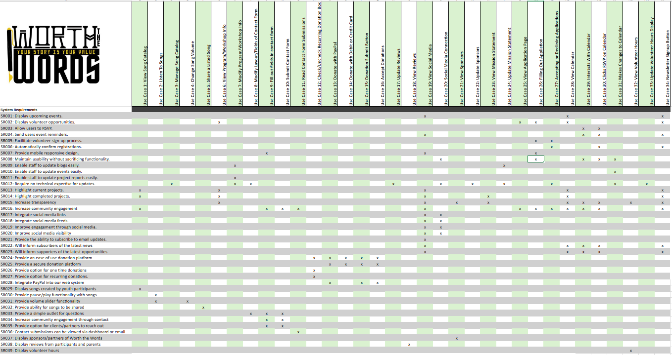

**Initial Architecture Considerations**

Our team decided that the best approach for the "Worth The Words" website redesign was to fully integrate the new design within the existing website, avoiding the need for a subdomain or separate platform. The WIX platform was chosen for its ease of use, offering a built-in content management system (CMS), payment management, and hosting capabilities. This allows the website to be managed without requiring extensive technical expertise.

Initially, we explored other CMS options like WordPress or Drupal. However, after discussions with the stakeholders, we decided that WIX would offer a more efficient and cost-effective solution for the nonprofit’s needs. WIX’s native integration with PayPal will handle donation processing, and its cloud-based infrastructure will provide reliable performance without requiring separate hosting services. The website will feature a mobile-responsive design, ensuring accessibility on both desktop and mobile devices. Event management will be integrated using WIX’s existing capabilities, with additional tools like Eventbrite considered for larger, more complex events.

In terms of architecture, the main focus will be on optimizing usability for both content managers and users. This involves providing a seamless experience for volunteers, donors, and community members, ensuring they can easily navigate the site, donate, and register for events.By leveraging WIX’s comprehensive toolset, we are ensuring that "Worth The Words" can maintain its website without additional technical support, while also enhancing the user experience for all stakeholders.

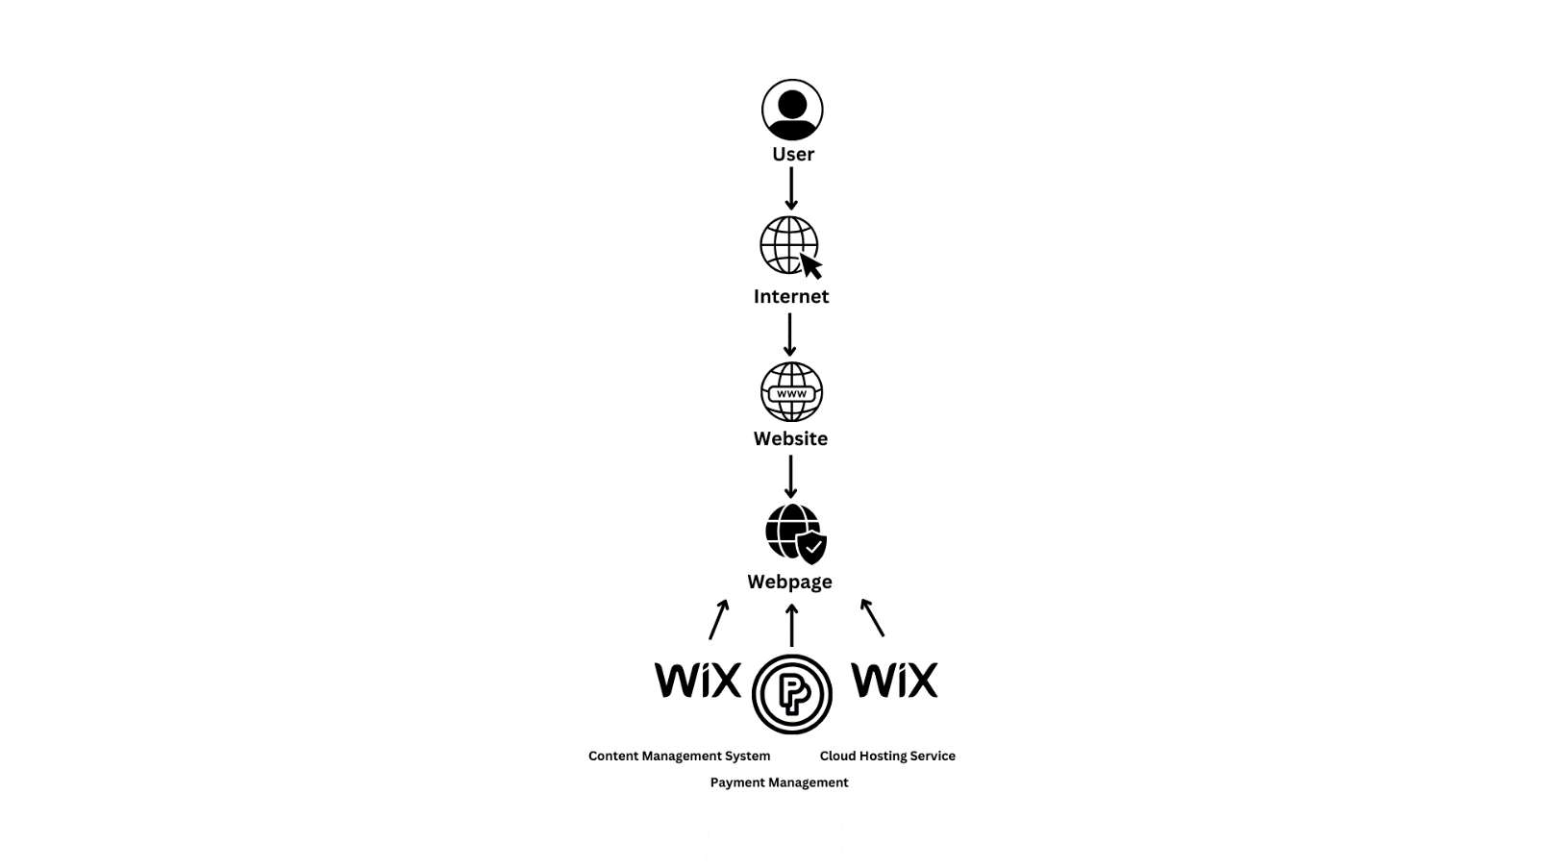**Initial Design View**

**Realistic Design View**

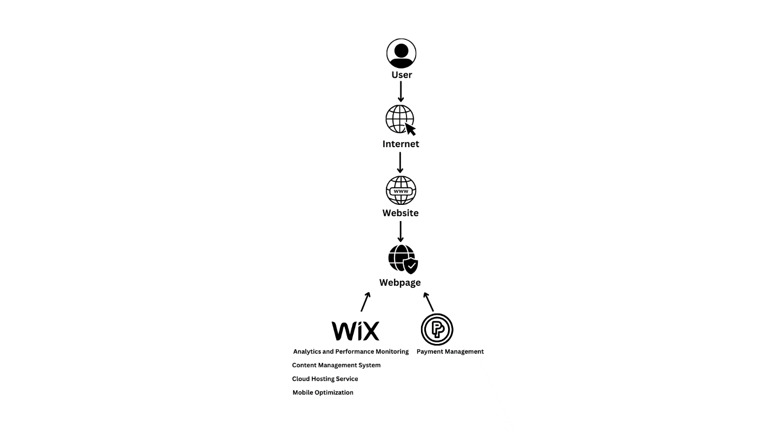

**Risk Analysis**

When evaluating the risk of each of our uses cases our main considerations were with certain website backend related processes as they are crucial to our system’s operation, and with data security as that is identified as one of our priority project constraints. Website backend related processes are high risk because non-approved edits to the non-functional information such as our mission statement could negatively affect our marketing and image while non-approved access or edits to functional features such our donation management could jeopardize the system. Donation management/processing and securing user data inputs from our various forms are the two biggest data security risks related to our system. As a 501(c)(3) non-profit organization, Worth the Words’s main income source is from donations so establishing and maintaining trust with clients and donors is a priority.

Wix has multiple built-in features to mitigate some of our high-risk cases. Our Wix plan includes a built-in WAF and SSL encryption which heavily mitigates our security risks. Web application firewall (WAF) blocks malicious traffic from the website, while Secure Socket Layer (SSL) encryption will encrypt data being transferred throughout our system. Throughout the elaboration phase, we will add, change, or remove certain risk factors based on the amount of scope creep that will occur between phases.

**High Risk Use Cases**

* Calendar/Event management
* Donation management
* Donation processing
* Song catalog management
* Non-functional information management (Program info, reviews, etc.)
* Securing user data from inputs (Contact form, RSVP)

**Low Risk Use Cases**

* Viewing, listening, and sharing participants' songs
* Filling out contact and application forms
* Switching website tabs (ex: from home page to contact)
* Viewing nonfunctional information (sponsors, mission statement, reviews, etc.)
* Viewing and interacting with the calendar
* Interacting with social media posts

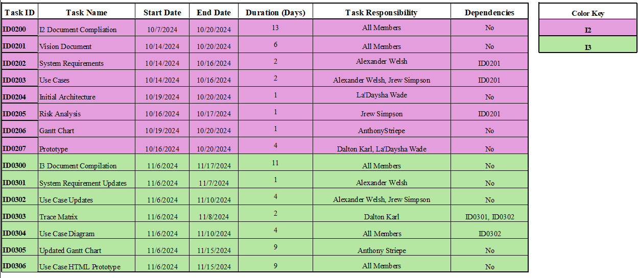**Gantt Chart**

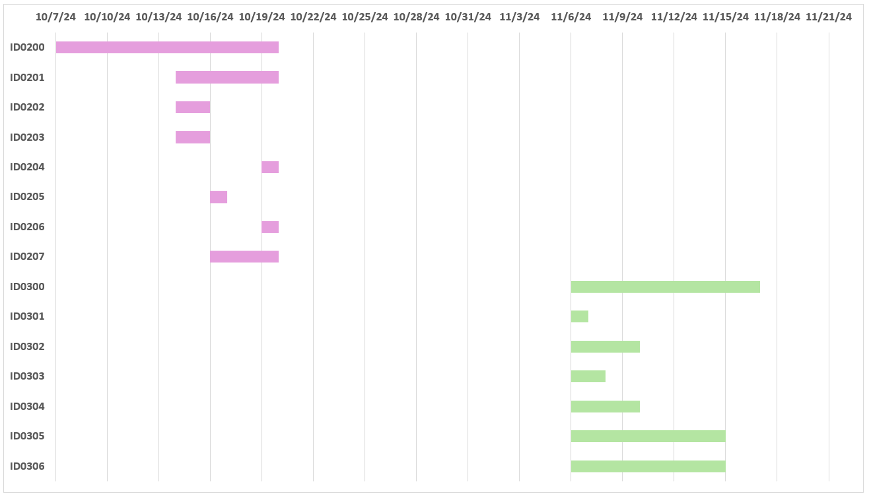

**Inception Phase Prototype**

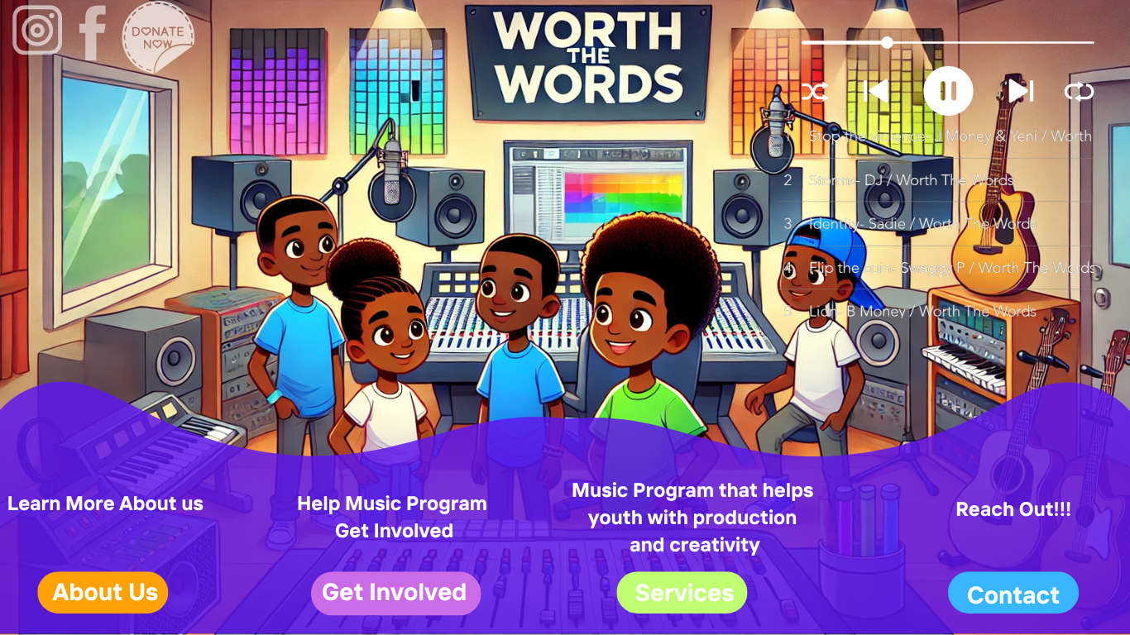

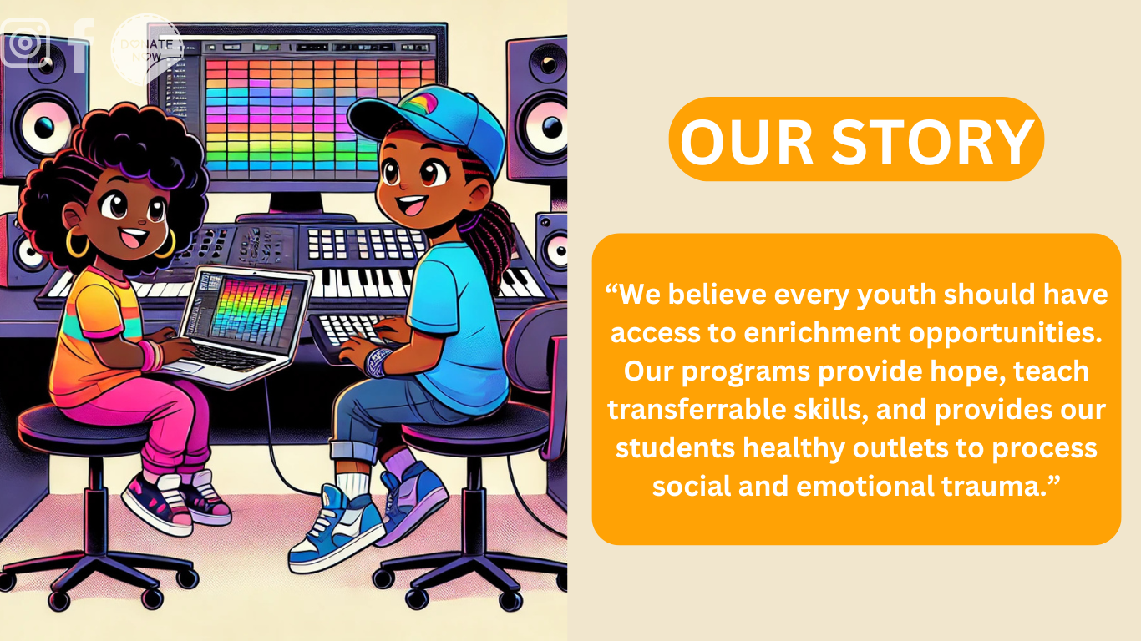

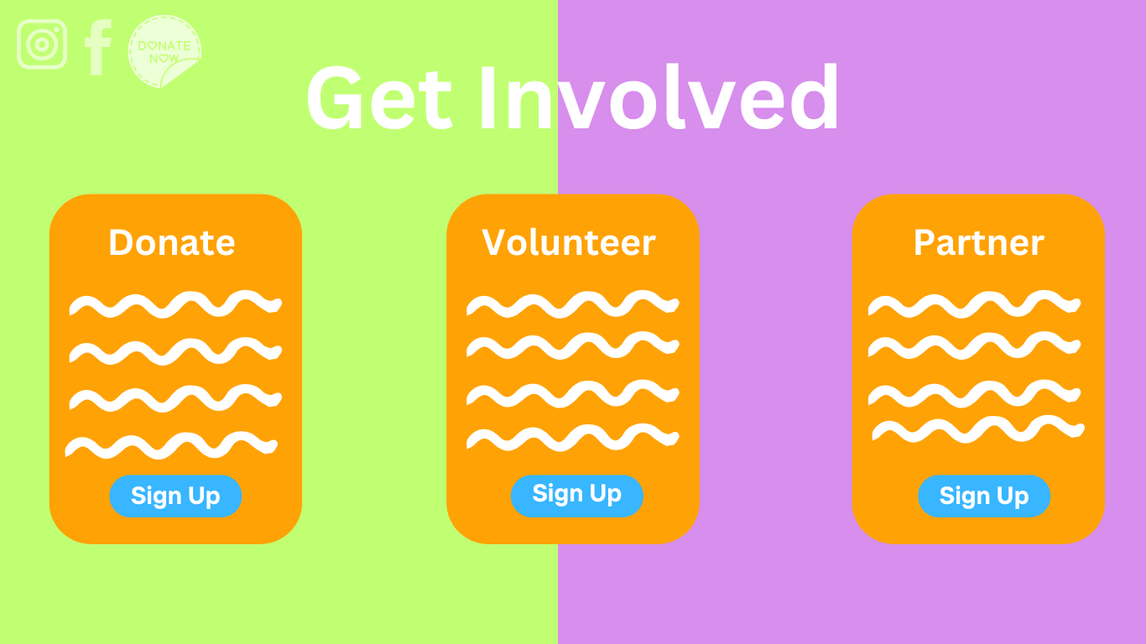

**Appendix A**

**1. Overview**

The goal of this project is to redesign the Worth the Words website to increase donations and volunteer engagement. This analysis evaluates the costs and projected financial benefits over the next five year

**2. Technical Feasibility**

We will continue using the WIX platform for the website, as it is easy to manage and allows for future growth. The initial setup includes configuring donation tools and adding important features like volunteer sign-ups.

**Setup Costs (Year 1)**: $500 for customization and professional setup

**Platform**: WIX Core Plan at $348/year for hosting and maintenance

**Additional Tools**: $150 for premium apps (volunteer sign-up, donation management)

**3. Economic Feasibility**

In Year 1, total costs will be $998 due to setup expenses. Starting in Year 2, the costs drop to $348 for WIX, with a small 5% increase each year for inflation. The income for each year comes from a combination of expected donations and the grant from Metro United Way. This grant provides **$916** a month, and we project the donation volume to increase by 10% each year. The total income over five years is projected to be **$59,831**, while the total costs come to **$1,772**, leaving a positive NPV of **$59,832** over the five-year period.

**4. Operational Feasibility**

The WIX platform is user-friendly and requires minimal training for volunteers or staff to manage. Updates, donations, and volunteer coordination can be handled efficiently through the system's dashboard. This keeps operational efforts low and allows the organization to focus on its mission.

5. **Conclusion**

The website redesign is feasible, with an affordable setup cost and steady income growth projected over the next five years. With low recurring costs and a positive return on investment, the project is sustainable and will significantly enhance engagement and fundraising capabilities.

[Link to Excel Document](https://cardmaillouisville-my.sharepoint.com/:x:/g/personal/alstri02_louisville_edu/EfX6JeEe1ElGkNao6RGy220BSNmd0InLjciUv5RMF5FT6A?e=3yY7sh)

